## Maintenance Project (420-E71-HR)

# *Task 5 – Retrospective – Sprint 1 & Mid-term review*

Date assigned: Thursday, April 5, 2018

Date due: **Monday, April 9, 2018, 12h00**

**Learning Objectives**

Upon successful completion of these tasks, the project team will have:

* Completed a group retrospective for Sprint 1
* Perform a self-evaluation of your performance on the project team
* Completed a peer review for Sprint 1

To do:

# Section A - Group Retrospective And Plan– Prepare

Before participating in the group retrospective, ensure the following tasks are done and complete the checklist.

|  |  |
| --- | --- |
| Task | Completed (Y/N) |
| TFS is updated for “hours remaining” on any of your outstanding tasks. The state of all your assigned tasks are correct. | Y |
| TFS is updated to track all relevant issues | Y |
| Recap the meeting minutes and achieve group consensus that it captures all the decisions and actions. | Y |

# Section B – Self Analysis

Answer each of the following questions by thinking about your contribution to this course so far. Consider only the work you have performed so far in this course.

1. With the introductory work and the first two sprints complete, what has been your greatest contribution to the class overall?

I feel as though my biggest contribution to the team was helping the team get on track for having the whole team organized and communicating. I had a lot of initial ideas about how we could organize and divide the work, and I got us communicating over discord.

1. What area(s) of your work in this class have given you the most satisfaction and why?

I suppose getting the whole team onto discord to have a universal method of communication. It’s been helpful having one place to go where I can reach anyone on the team.

1. What area(s) of your work in this class have been dissatisfying and why?

I feel like in terms of actual work done on the system, I’ve done very very little. I was initially working on some coop stuff, not recognizing that coop and eCoop were the same thing, so my first 2 weeks of work were essentially thrown out. I already wasn’t feeling too great about maintenance, so I’d been pretty slow to get those working, but then I feel like productivity halted for a while after that.

1. What are your specific strengths and skills when it comes to maintenance?

I don’t feel like I have particular strengths geared towards maintenance in particular. I feel like I’m not bad at taking a look at the system that I didn’t build and walking through the code to figure out what everything does.

1. What are your specific weaknesses and areas of improvement when it comes to this course or maintenance in general?

In terms of this course, my biggest weakness is my lack of motivation to be getting work done. I’ve been very slow at doing anything.

1. How could you be more helpful to the people on the team (or in the class)?

I could be more helpful to the team by trying to up my attitude and productivity. In the next sprint I’m going to be working on the log in API, which is new functionality, so I’m hoping that will help significantly. It’s something I’m interested in doing for the sake of this system, the ones currently in production and future systems.

1. Briefly discuss providing feedback to your peers (even though they did not see it). What were the challenges in evaluating your peers? Is it a worthwhile exercise for YOUR development to attempt to provide honest feedback in that manner?

I have no problem providing honest feedback about my peers I find. I don’t typically give “sunshine marks” to them, and try to be as honest as possible, even if it’s not in their favour. I personally don’t feel like I find it necessary for my development to look at the work of others. I know that I didn’t do well, regardless of whether I’ve compared myself to others on the team. I know my areas for improvement.

1. If you were a hiring manager right now, given your work in this course ONLY, would you hire the “you” from this course? Why or why not?

Honestly, no. I’ve not done a whole lot of work the past few weeks, and the work that I have done hasn’t been the greatest.

# Section C - Group Retrospective

### **Sprint 1retrospective:**

Have a group retrospective and capture the following:

This sprint’s Retrospective:

What went well?

I feel as though the team as a whole was very well organized, everyone had a role, and everyone knew what they were doing.

What didn’t go so well?

A lot of people didn’t use discord a whole lot to communicate with us, which meant a handful of people were out of the loop on what was going on. I feel like there was also a handful of people on the team who were working, and a handful who were slacking off or procrastinating, or whatever you want to call it, weren’t working as much as they could’ve – myself especially included.

What have we learnt?

I feel like we’ve learnt that re-writing a system like this isn’t so linear and 1:1 as I’d first thought it would be. Especially changing from WebForms to MVC, we were able to keep a couple classes as 1:1, but we had to re-write a lot of the code.

What is still mysterious?

There’s a couple things about the log in API that I need to figure out, and the query to add a new semester is something I’ve not looked at at all, so it’s somewhat of a mystery to me at least.

What bugs us?

There’s nothing currently bugging me.

How close were your effort estimates?

My estimates were usually too low, but that’s just because of working slowly. I could’ve easily completed all my tasks within the estimated time but ended up not just because I was never in a headspace to work.

Capture outcomes: Decisions & Actions:

Please copy and paste a screen cap of your code coverage:

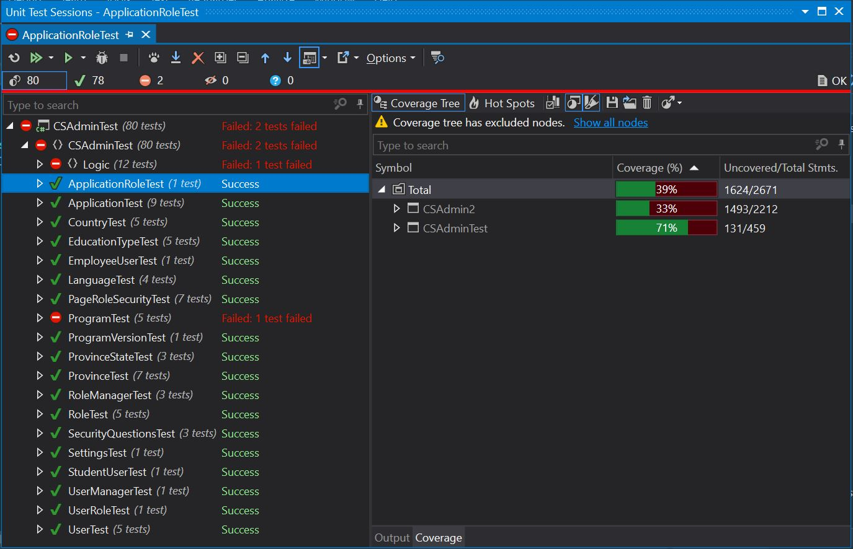

# Section D - Peer Review

See PASS invitation for the peer review.

Make sure you provide constructive criticism to the other members. Note: AND THIS IS IMPORTANT. This is an exercise in how you provide feedback. The marks you allot will not only factor into the other person(s)’ mark, but will factor into your mark. So make sure you provide honest, direct and constructive feedback as YOU are being evaluated on your ability to provide feedback. This will account for 2% of your final mark.

Yes, you have to know what your team mates are working on daily. It’s why we have those daily scrums.

You **MUST provide comments** for any mark that is a 1 (Unsatisfactory) or 4 (Exceptional). List specific examples if you can.

**To submit**

Submit to Moodle